Press Release

GUANDONG ANNOUNCES THE ENTRY OF GIOVANARDI
INTO ITS SHAREHOLDING STRUCTURE

May 19, 2023: Guandong, specialized in the development and marketing of innovative materials and media for printing and recognized at European level as a Specialist of Specialties, announces the entry of the Giovanardi Group into the shareholding structure, a reference point for technical fabrics in the field of sun shading, architecture, transport, boating, advertising, design and printing. On May 18th, in fact, the financial company ELVI Holding signed an agreement with the Giovanardi Investment Company that enters Guandong Italia with majority shares.

"On the journey we began in 2007, Guandong has increasingly acquired authority in the international market, becoming a brand recognized throughout Europe", begins Edoardo Elmi, founder of Guandong. "Today we are an extremely dynamic reality, too big to act with the logic of a small company, but too small to plan for the future with the correct approach for the European market. We realized that to continue on our path of growth we need new resources, and my long-time partner Alberto Vincenzi and I feel its our duty, also a moral one, to give continuity to the company within the European context". With the ironic trait that distinguishes him, Edoardo Elmi adds: "Even if some consider us highlanders, Alberto and I are no longer two young things and our age implies the need for a new contribution". Elmi underlines that ELVI Holding will remain in the shareholding structure of Guandong to ensure continuity in the development path and to support a synergistic integration with Giovanardi.

To introduce the new majority shareholder, Edoardo Elmi states he is particularly happy to "have met a 'thoroughbred entrepreneur', who has been able to develop the company on various technical textile markets and who operates according to principles that are very similar to ours, managing the family business with values linked to tradition, but looking at the market with an innovative approach". Indeed, despite having reached an international dimension, Giovanardi has been able to remain faithful to its origins as a family business.

60 years after its foundation, the company is now led by brothers Daniela and Carlo Giovanardi, and it is the latter who comments on the entry into Guandong through the family financial company. "Our wish is that the company continues to do its job as it has always done. Continuing the technical and technological development plan, with a strong orientation towards the field of eco-sustainability and foreign markets. On our side, we will guarantee what Guandong needs, which is security and continuity." Giovanardi also underlines the great synergism between the two realities: "The already consolidated presence of Guandong abroad may be useful to the commercial policy of Giovanardi’s core products. At the same time, we can contribute to the further growth of Guandong, already the undisputed leader in plastic materials, also in the world of textiles for printing and interior decoration".

Guandong and Giovanardi will continue to operate independently with their respective sales networks. The Guandong’s management confirms the policy undertaken so far, as explained by Daniele Faoro, Chief Sales & Marketing Advisor. "We will continue to develop the sales network, especially abroad, continuing to work with our international network of distributors who, in turn, interface with printing operators. We also confirm our commitment to continue to be the 'specialists of specialties', our prerogative that the whole European market recognizes".
PICTURES:

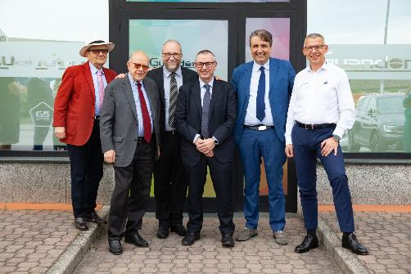

Picture 1) From left: Edoardo Elmi, Alberto Vincenzi, Guido Tescaroli, Carlo Giovanardi, Fabio Elmi, Daniele Faoro

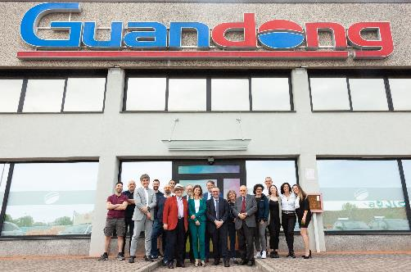

Picture 2) Guandong Headquarter

For the press:
Pinkommunication
Cristina Cortellezzi
Laura Premoli
info@pinkommunication.it

For the public:
Guandong Italia Srl
SS 415 Paullese Km 10
20090 Caleppio di Settala (MI)
Phone +39 02 89785988
info@guandong.eu - www.guandong.eu
Giovanardi Investment Company Srl
Viale Bianca Maria, 41
20122 Milano
Phone +39 0376 572011
info@giovanardi.it - www.giovanardi.com

